MONOLE L’UNAM pour l’EAIE

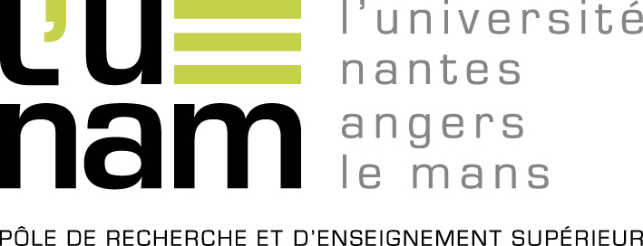

L’Université Nantes Angers Le Mans agglomerates 29 research and higher education establishments in the Pays de la Loire Region in order to take its place within the competitive arena of the international scientific community.

L’UNAM implements guidelines and structured research programs, promotes the doctoral training in conjunction with these strong guidelines and insures an attractive international visibility for its member establishments.

Key figures
11 founding members
18 associate members
76,000 students including 2,300 PhD students
11,000 personnel including 4,200 researchers and lecturers
129 laboratories
9 PhD schools training more than 400 PhD students

Joindre le logo + quelques photos

